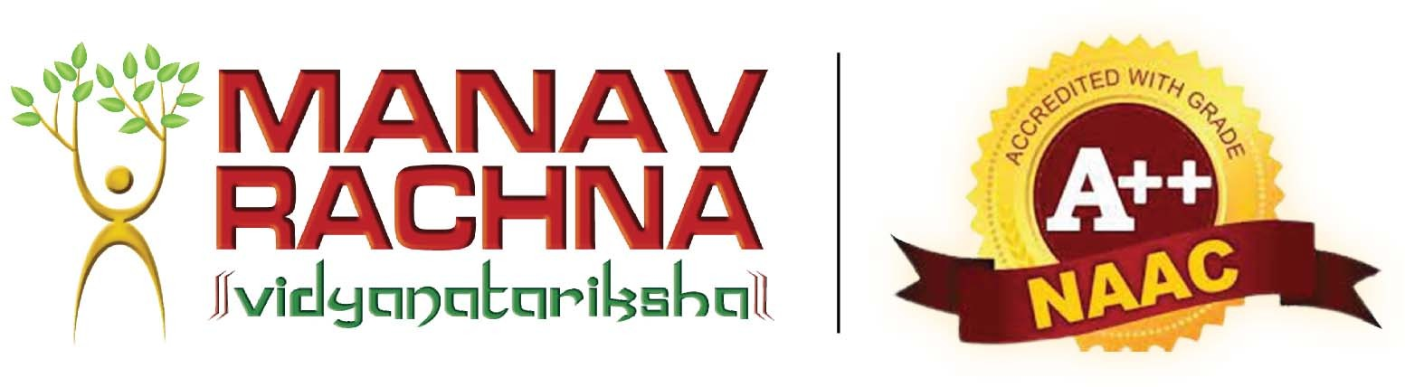

Design Thinking and Innovation II (DTI-400)

Resume Building Website (TalentCrafters)

# Submitted By:

|  |  |  |
| --- | --- | --- |
| **Student’s Name** | **Student’s Roll no.** | **Branch** |
| Anmol Negi | 1/22/FET/BCS/131 | Btech CSE-N 4C1 |
| Kartik | 1/22/FET/BCS/168 | Btech CSE-N 4C2 |
| Aayush Kukreja | 1/22/FET/BCS/159 | Btech CSE-N 4C1 |

Under the Guidance of Dr. Shobha Tyagi

Bachelor of Technology in

Computer Science and Engineering

**Introduction:**

The resume-building website aims to provide users with a convenient platform for creating professional resumes tailored to their needs. Leveraging modern web technologies, the website offers user-friendly interfaces and robust functionalities to streamline the resume creation process.

**Objectives:**

* To develop a user-friendly platform for creating professional resumes.
* To integrate essential features such as user registration, profile management, and resume generation.
* To provide users with the ability to download resumes in PDF format for easy sharing and printing.
* To establish a foundation for future integration of AI technologies to enhance resume creation and template recommendations.

**Proposed Methodology:**

* Design and development of the website architecture, including database setup and user authentication mechanisms.
* Implementation of core functionalities such as user registration, login, profile management, and resume creation using HTML, CSS, JavaScript, and backend technologies.
* Integration of PDF generation capabilities for downloadable resumes.
* Incorporation of additional pages for contact and password recovery functionalities.
* Continuous testing and refinement to ensure usability, performance, and security.

**Key Features:**

* User Registration and Login: Secure authentication system for user accounts.
* Profile Management: Customizable user profiles for managing personal and professional details.
* Resume Creation: Intuitive interface for entering and formatting resume content.
* PDF Download: Ability to download generated resumes in PDF format.
* Contact and Password Recovery: Pages for contacting support and recovering forgotten passwords.

**Anticipated Outcomes:**

* Enhanced user experience through intuitive interface design and streamlined workflows.
* Increased user engagement and satisfaction resulting from personalized resume creation capabilities.
* Improved accessibility and convenience for users seeking professional resume-building services.
* Establishment of a scalable platform capable of integrating advanced AI technologies for future enhancements.

**Conclusion:**

Our resume-building website represents a significant step forward in empowering users to create professional resumes online with ease and convenience. By combining user-centric design principles with robust functionalities and future scalability, we aim to provide users with a valuable resource for advancing their careers and achieving their professional goals in today's competitive job market.